**DAY 4 – SELENIUM TESTNG BASICS ASSIGNMENT**

### **Sample TestNG Test Case**

package firsttestngpackage;

import org.openqa.selenium.*;

import org.openqa.selenium.firefox.FirefoxDriver;

import org.testng.Assert;

import org.testng.annotations.*;

public class firsttestngfile {

public String baseUrl = "http://demo.guru99.com/test/newtours/";

String driverPath = "C:\\geckodriver.exe";

public WebDriver driver ;

@Test

public void verifyHomepageTitle() {

System.out.println("launching firefox browser");

System.setProperty("webdriver.firefox.marionette", driverPath);

driver = new FirefoxDriver();

driver.get(baseUrl);

String expectedTitle = "Welcome: Mercury Tours";

String actualTitle = driver.getTitle();

Assert.assertEquals(actualTitle, expectedTitle);

driver.close();

}

}

### **Running the Test**

To run the test, simply run the file in Eclipse as you normally do. Eclipse will provide two outputs – one in the Console window and the other on the TestNG Results window.

[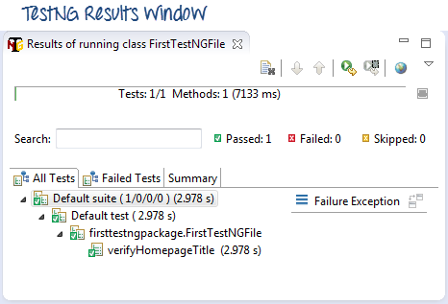](https://www.guru99.com/images/testng_results_window-0025.png)

[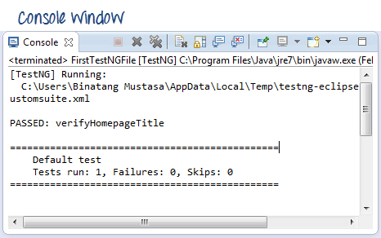](https://www.guru99.com/images/console_window-0023.png)

## Checking reports created by TestNG

The Console window in Eclipse gives a text-based report of our test case results while the TestNG Results window gives us a graphical one.

[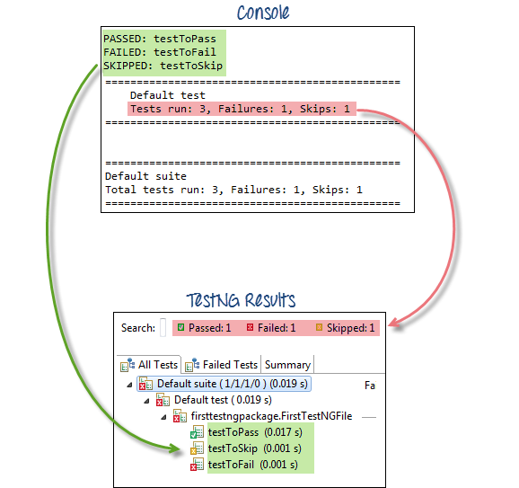](https://www.guru99.com/images/text_vs_graphical-0016.png)

### Generating HTML Reports

TestNG has the ability to generate reports in HTML format.

**Step 1:**After running our FirstTestNGFile that we created in the previous section, right-click the project name (FirstTestNGProject) in the Project Explorer window then click on the "Refresh" option.

[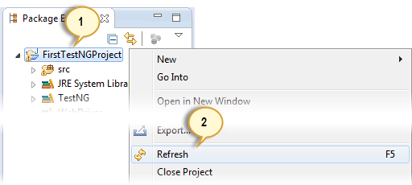](https://www.guru99.com/images/step_1-0019.png)

**Step 2:**Notice that a "test-output" folder was created. Expand it and look for an index.html file. This HTML file is a report of the results of the most recent test run.

[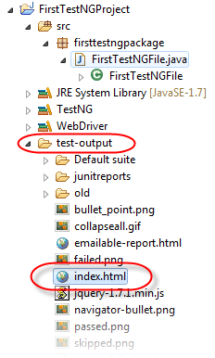](https://www.guru99.com/images/test-output___index-0022.png)

**Step 3:**Double-click on that index.html file to open it within Eclipse's built-in web browser. You can refresh this page any time after you rerun your test by simply pressing F5 just like in ordinary web browsers.

[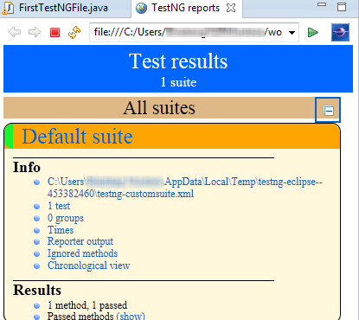](https://www.guru99.com/images/3-1-2013_4-58-41_PM.png)

1. **Multiple Annotations Example**

package firsttestngpackage;

import org.openqa.selenium.*;

import org.openqa.selenium.firefox.FirefoxDriver;

import org.testng.Assert;

import org.testng.annotations.*;

public class firsttestngfile {

public String baseUrl = "http://demo.guru99.com/test/newtours/";

String driverPath = "C:\\geckodriver.exe";

public WebDriver driver ;

@BeforeTest

public void launchBrowser() {

System.out.println("launching firefox browser");

System.setProperty("webdriver.firefox.marionette", driverPath);

driver = new FirefoxDriver();

driver.get(baseUrl);

}

@Test

public void verifyHomepageTitle() {

String expectedTitle = "Welcome: Mercury Tours";

String actualTitle = driver.getTitle();

Assert.assertEquals(actualTitle, expectedTitle);

}

@AfterTest

public void terminateBrowser(){

driver.close();

}

}

## **Summary of TestNG Annotations**

**@BeforeSuite**: The annotated method will be run before all tests in this suite have run.

**@AfterSuite**: The annotated method will be run after all tests in this suite have run.

**@BeforeTest**: The annotated method will be run before any test method belonging to the classes inside the tag is run.

**@AfterTest**: The annotated method will be run after all the test methods belonging to the classes inside the tag have run.

**@BeforeGroups**: The list of groups that this configuration method will run before. This method is guaranteed to run shortly before the first test method that belongs to any of these groups is invoked.

**@AfterGroups**: The list of groups that this configuration method will run after. This method is guaranteed to run shortly after the last test method that belongs to any of these groups is invoked.

**@BeforeClass**: The annotated method will be run before the first test method in the current class is invoked.

**@AfterClass**: The annotated method will be run after all the test methods in the current class have been run.

**@BeforeMethod**: The annotated method will be run before each test method.

**@AfterMethod**: The annotated method will be run after each test method.

**@Test**: The annotated method is a part of a test case

1. **TestNG Priorities**

package firsttestngpackage;

import org.openqa.selenium.*;

import org.openqa.selenium.firefox.FirefoxDriver;

import org.testng.Assert;

import org.testng.annotations.*;

@Test

public class firsttestngfile {

public String baseUrl = "http://demo.guru99.com/test/newtours/";

String driverPath = "C:\\geckodriver.exe";

public WebDriver driver;

public String expected = null;

public String actual = null;

@BeforeTest

public void launchBrowser() {

System.out.println("launching firefox browser");

System.setProperty("webdriver.firefox.marionette", driverPath);

driver= new FirefoxDriver();

driver.get(baseUrl);

}

@BeforeMethod

public void verifyHomepageTitle() {

String expectedTitle = "Welcome: Mercury Tours";

String actualTitle = driver.getTitle();

Assert.assertEquals(actualTitle, expectedTitle);

}

@Test(priority = 0)

public void register(){

driver.findElement(By.linkText("REGISTER")).click() ;

expected = "Register: Mercury Tours";

actual = driver.getTitle();

Assert.assertEquals(actual, expected);

}

@Test(priority = 1)

public void support() {

driver.findElement(By.linkText("SUPPORT")).click() ;

expected = "Under Construction: Mercury Tours";

actual = driver.getTitle();

Assert.assertEquals(actual, expected);

}

@AfterMethod

public void goBackToHomepage ( ) {

driver.findElement(By.linkText("Home")).click() ;

}

@AfterTest

public void terminateBrowser(){

driver.close();

}

}

1. **Test NG Groups**

<?xml version="1.0" encoding="UTF-8" ?>

<!DOCTYPE suite SYSTEM "http://testng.org/testng-1.0.dtd">

<suite name="**Suite**">

<test name="**Guru 99 Smoke Test Demo**">

<groups>

<run>

<include name="strong_ties" />

</run>

</groups>

<classes>

<class name="**com.group.guru99.TC_Class1**" />

</classes>

</test>

</suite>

package com.group.guru99;

import java.util.concurrent.TimeUnit;

import org.openqa.selenium.By;

import org.openqa.selenium.WebDriver;

import org.openqa.selenium.firefox.FirefoxDriver;

import org.testng.Assert;

import org.testng.annotations.Test;

public class TC_Class1 {

public static final WebDriver webDriver = new FirefoxDriver();;

String launchPageHeading = "//h3[text()='Guru99 Bank']";

final String userName_element = "//input[@name='uid']", password_element = "//input[@name='password']",

signIn_element = "//input[@name='btnLogin']";

final String userName_value = "mngr28642", password_value = "ydAnate";

final String managerID = "//td[contains(text(),'Manger Id')]";

final String newCustomer = "//a[@href='addcustomerpage.php']", fundTransfer = "//a[@href='FundTransInput.php']";

/**

* This test case will initialize the webDriver

*/

@Test(groups = { "bonding", "strong_ties" })

public void tc01LaunchURL() {

webDriver.manage().window().maximize();

webDriver.manage().timeouts().implicitlyWait(20, TimeUnit.SECONDS);

webDriver.get("http://www.demo.guru99.com/V4/");

}

/**

* Will check the presence of Heading on Login Page

*/

@Test(groups = { "bonding" })

public void tc02VerifyLaunchPage() {

Assert.assertTrue(webDriver.findElement(By.xpath(launchPageHeading)).isDisplayed(),

"Home Page heading is not displayed");

System.out.println("Home Page heading is displayed");

}

/**

* This test case will enter User name, password and will then click on

* signIn button

*/

@Test(groups = { "bonding", "strong_ties" })

public void tc03EnterCredentials() {

webDriver.findElement(By.xpath(userName_element)).sendKeys(userName_value);

webDriver.findElement(By.xpath(password_element)).sendKeys(password_value);

webDriver.findElement(By.xpath(signIn_element)).click();

}

/**

* This test case will verify manger's ID presence on DashBoard

*/

@Test(groups = { "strong_ties" })

public void tc04VerifyLoggedInPage() {

Assert.assertTrue(webDriver.findElement(By.xpath(managerID)).isDisplayed(),

"Manager ID label is not displayed");

System.out.println("Manger Id label is displayed");

}

/**

* This test case will check the presence of presence of New customer link

* And FundTransfer link in Left pannel

*/

@Test(groups = { "bonding" })

public void tc05VerifyHyperlinks() {

Assert.assertTrue(webDriver.findElement(By.xpath(newCustomer)).isEnabled(),

"New customer hyperlink is not displayed");

System.out.println("New customer hyperlink is displayed");

Assert.assertTrue(webDriver.findElement(By.xpath(fundTransfer)).isEnabled(),

"Fund Transfer hyperlink is not displayed");

System.out.println("Fund Transfer hyperlink is displayed");

}

}

## **Parallel Tests with Selenium**

**TestNG.XML**

<?xml version="1.0" encoding="UTF-8"?>

<!DOCTYPE suite SYSTEM "http://testng.org/testng-1.0.dtd">

<suite name="TestSuite" thread-count="3" parallel="methods" >

<test name="testGuru">

<classes>

<class name="TestGuru99MultipleSession">

</class>

</classes>

</test>

</suite>

import org.openqa.selenium.WebDriver;

import org.openqa.selenium.chrome.ChromeDriver;

import org.testng.annotations.Test;

public class TestGuru99MultipleSession {

@Test

public void executSessionOne(){

//First session of WebDriver

System.setProperty("webdriver.chrome.driver","chromedriver.exe");

WebDriver driver = new ChromeDriver();

//Goto guru99 site

driver.get("http://demo.guru99.com/V4/");

//find user name text box and fill it

driver.findElement(By.name("uid")).sendKeys("Driver 1");

}

@Test

public void executeSessionTwo(){

//Second session of WebDriver

System.setProperty("webdriver.chrome.driver","chromedriver.exe");

WebDriver driver = new ChromeDriver();

//Goto guru99 site

driver.get("http://demo.guru99.com/V4/");

//find user name text box and fill it

driver.findElement(By.name("uid")).sendKeys("Driver 2");

}

@Test

public void executSessionThree(){

//Third session of WebDriver

System.setProperty("webdriver.chrome.driver","chromedriver.exe");

WebDriver driver = new ChromeDriver();

//Goto guru99 site

driver.get("http://demo.guru99.com/V4/");

//find user name text box and fill it

driver.findElement(By.name("uid")).sendKeys("Driver 3");

}

}

References –

1. Selenium TestNG - <https://www.guru99.com/all-about-testng-and-selenium.html>v